HUMA Analysis

<https://journals.lww.com/jtrauma/fulltext/2023/08000/evaluation_of_vascular_repair_by_tissue_engineered.11.aspx>

* HUMA released pre-clin study looking at ATEV/ HAV vs ePTFE in porcine model
* N=36 pigs, 4 treatment groups
  + receiving either the HAV or a PTFE graft following a hind limb ischemia period of either 0 or 6 hours
  + 3cm by 6mm
  + In right eliac artery
  + Not immune suppressed for 1st mth
  + Eval: graft patency, hind limb function, biochem markers/ histology
  + Hind limb function and tissue damage biomarkers improved?
* Multiple typos in paper
* In methods say PTFE not ePTFE
* Paper below says infection rates wont be different btwn synth and nat
* Embolisms?
* 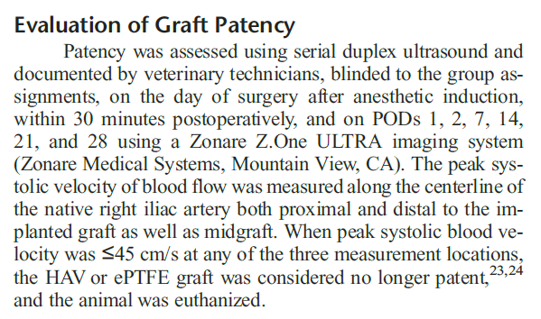

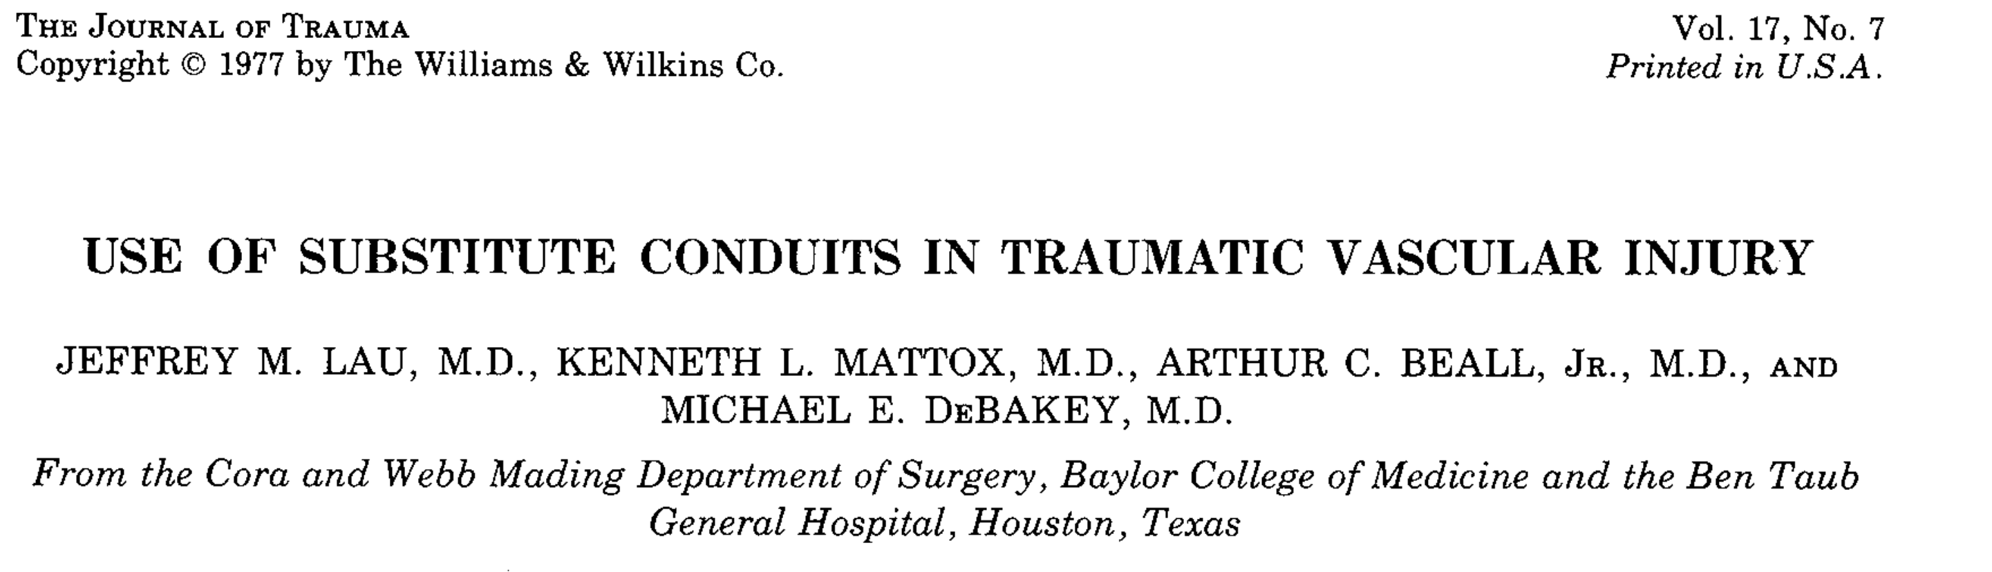

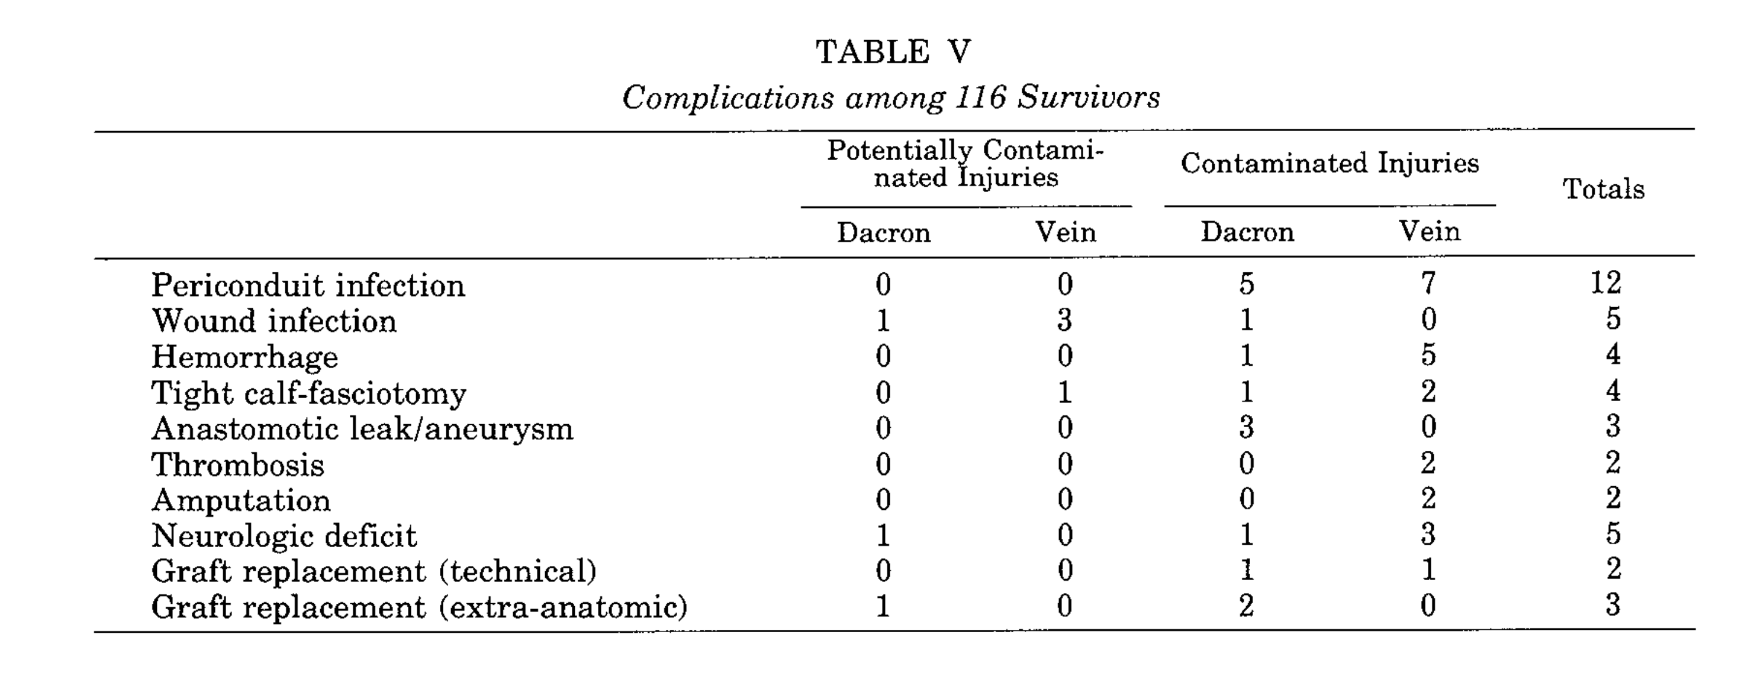

Rates of infection don’t differ much between synthetic and saphenous veins

https://www.ncbi.nlm.nih.gov/pmc/articles/PMC7768973/

* Vein grafts constituted 82% of the repairs and had a similar estimated patency of 93% compared with 81% for all other repairs.
* Proportion of scripts that are vein vs PTFE/ other?
* Upper extremity arterial cohort: Vein grafts constituted 90% of the repairs and had a patency of 97% compared with 33% for all other repairs (p<0.001; only five repairs were in this group).
* Lower extremity arterial patency: Lower extremity estimated arterial repair patency was 91% with median follow-up of 20 months

chrome-extension://efaidnbmnnnibpcajpcglclefindmkaj/https://www.fda.gov/media/158495/download

PTFE graft BLA

Meta analysis studies

Local response-

* Only have one rat study for local response.
* N=15, they report no foreign body giant cells (FBGCs) at

Devices:

* PTFE
* ePTFE
* HePTFE
  + Below-knee bypass 48mths primary patency: HePTFE 45.2% vs ASV 69%, p<0.001
  + Secondary patency: 57% HePTFE vs 67.5% ASV, p=0.1

HC Wainright call 09/10/2024

* Have treated 600 pts? Data??
* 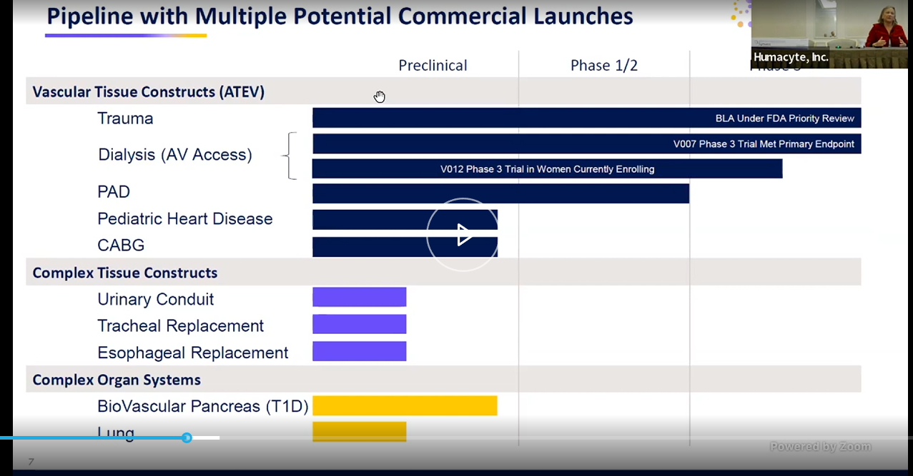
* DOD supported ph3 trial in BLA submission
* 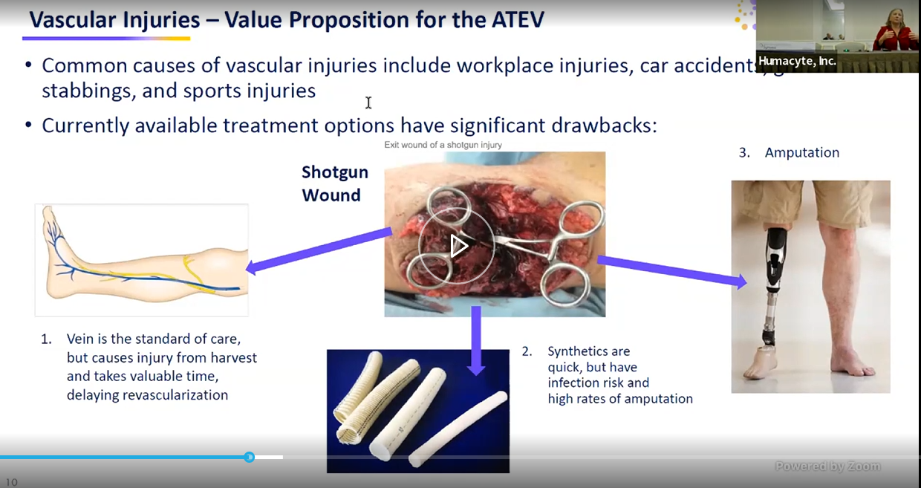
* She says infection rate is “quite high” on grafts vs their approach
* 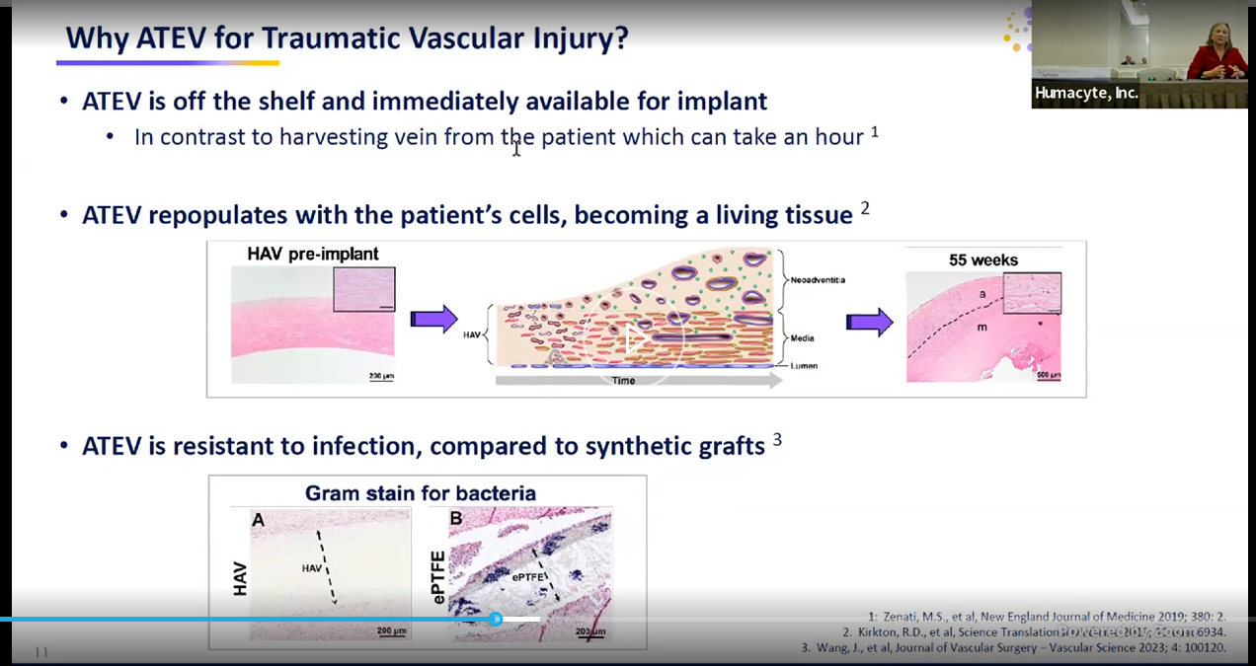
* 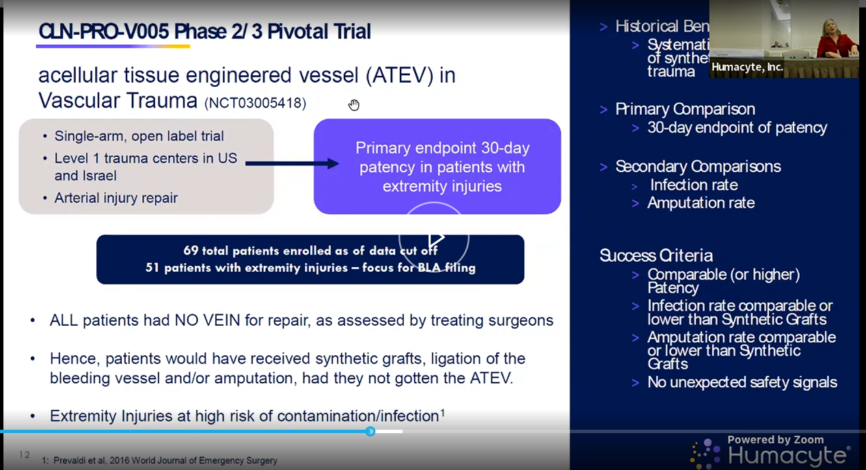
* Will follow pts for 3yrs on this study
* 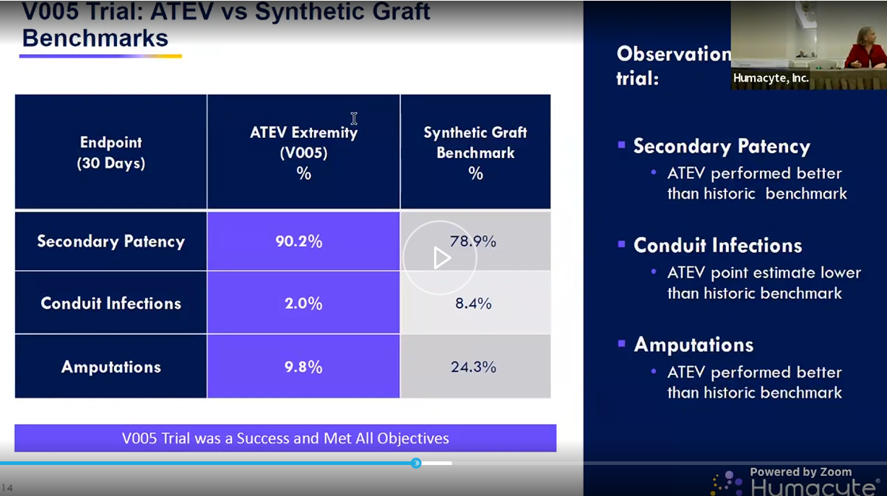
* 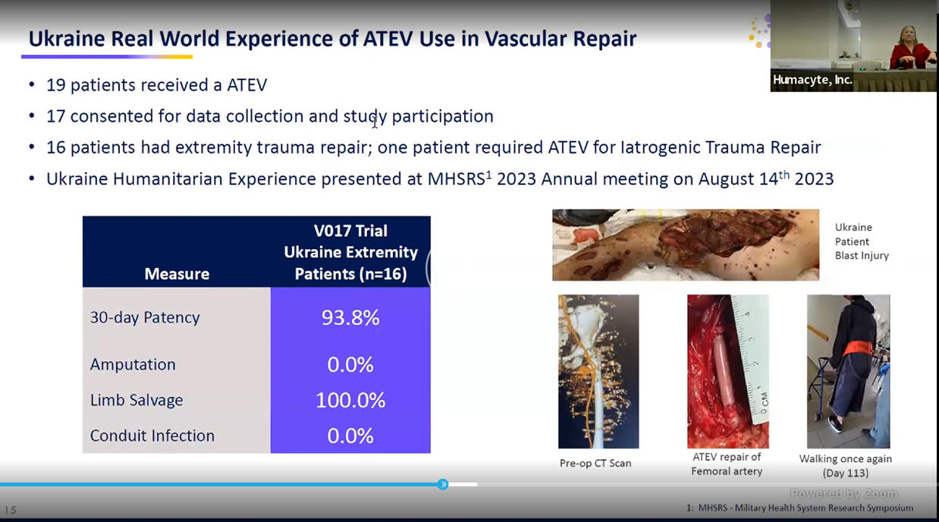
* Docs trained over zoom?
* 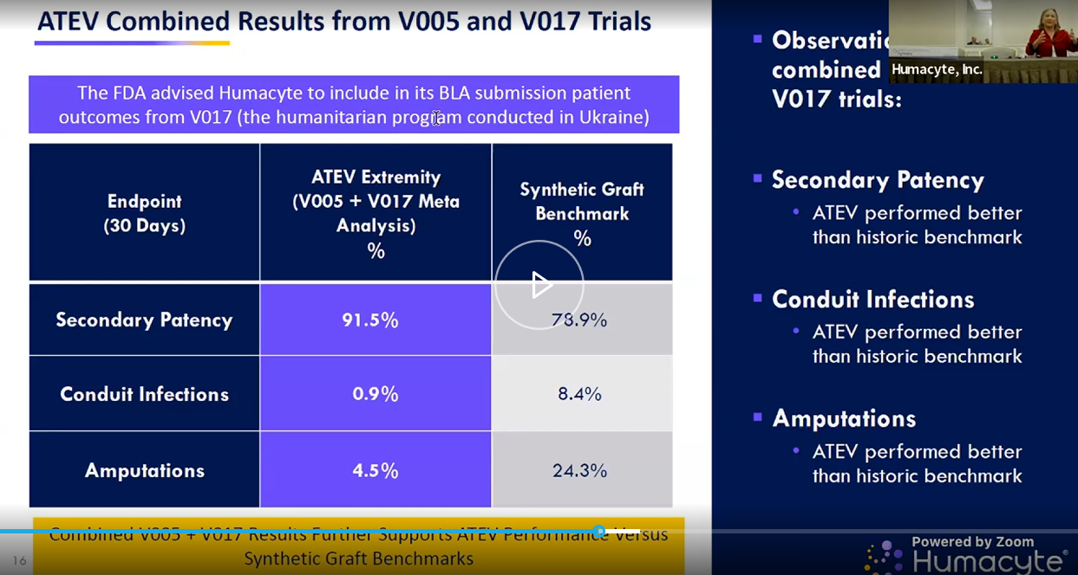
* 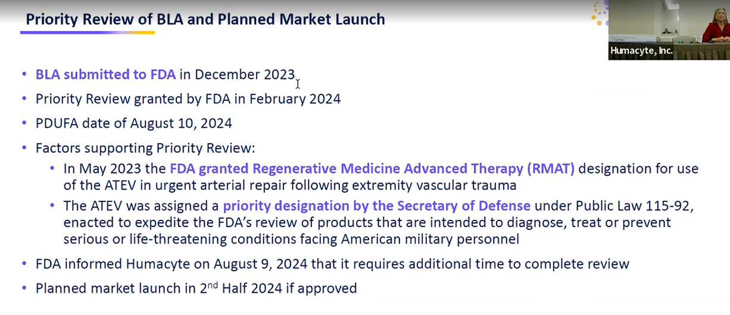
* “we’ve completed inspections and labelling talks and post approval commitments w FDA”
* “we do not have a new PDUFA data, expect to hear in coming weeks and months”
* 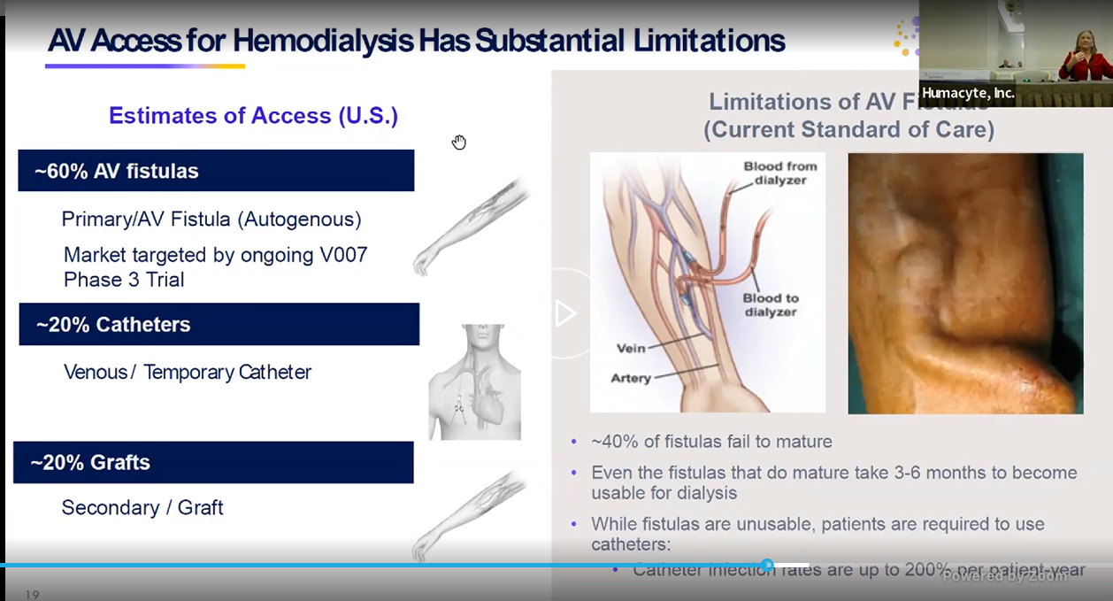
* 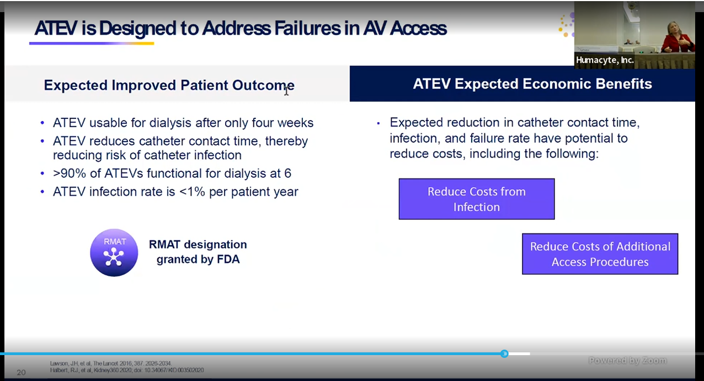
* 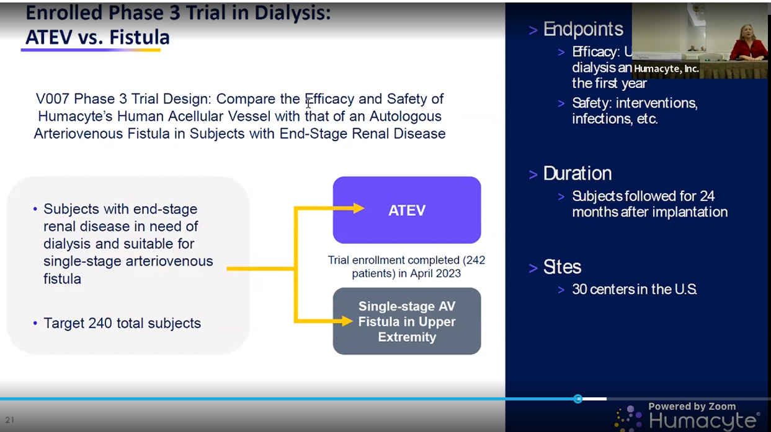
* 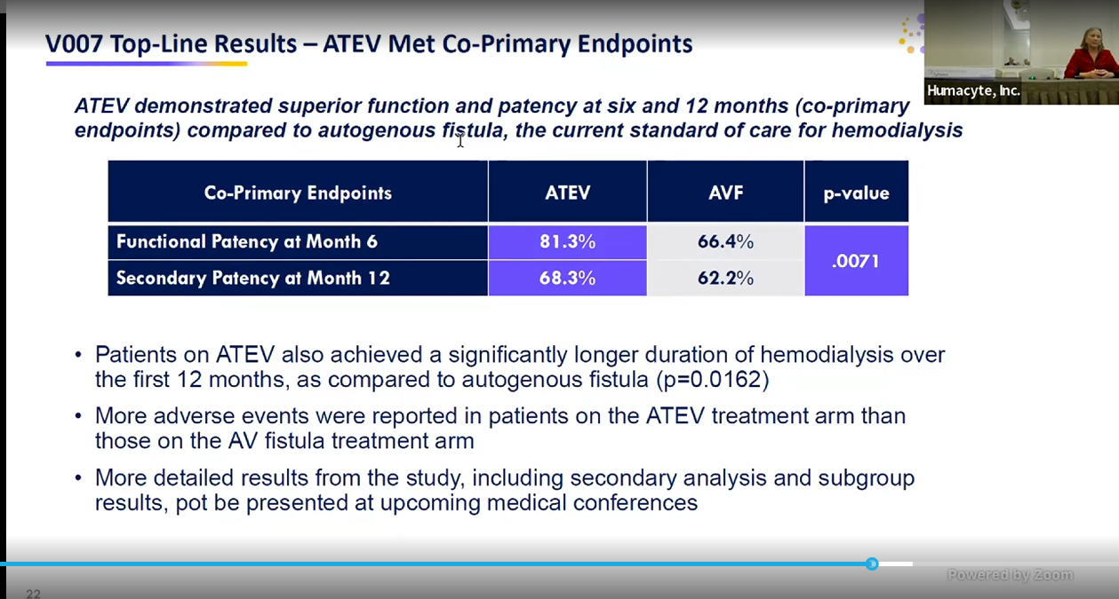
* Also have sub groups they are keen to share those with us soon! In several weeks at KOL webinar
* This study is done already
* 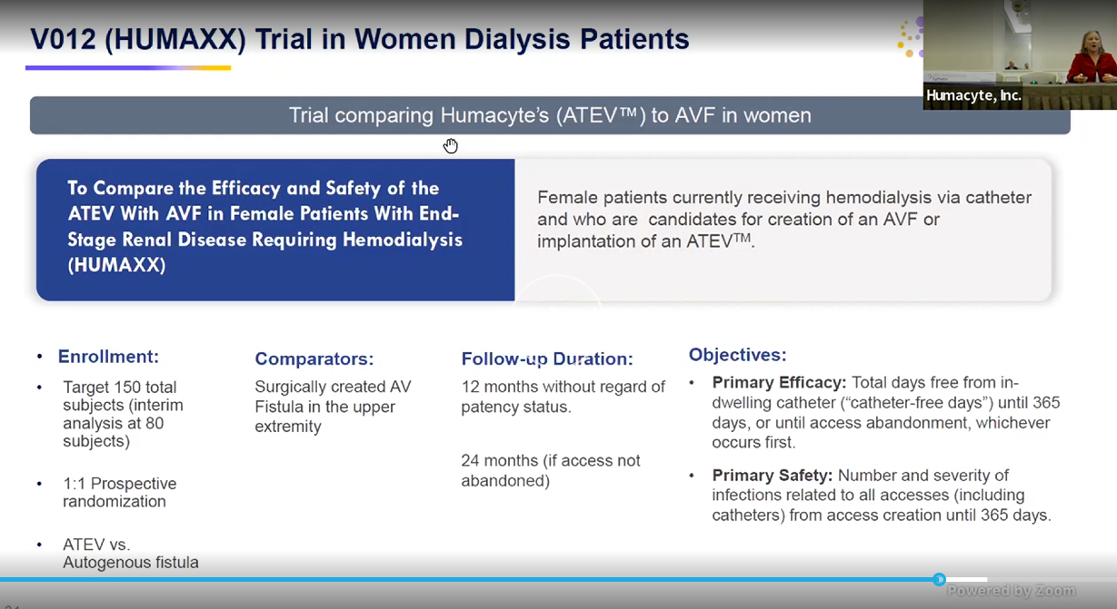
* 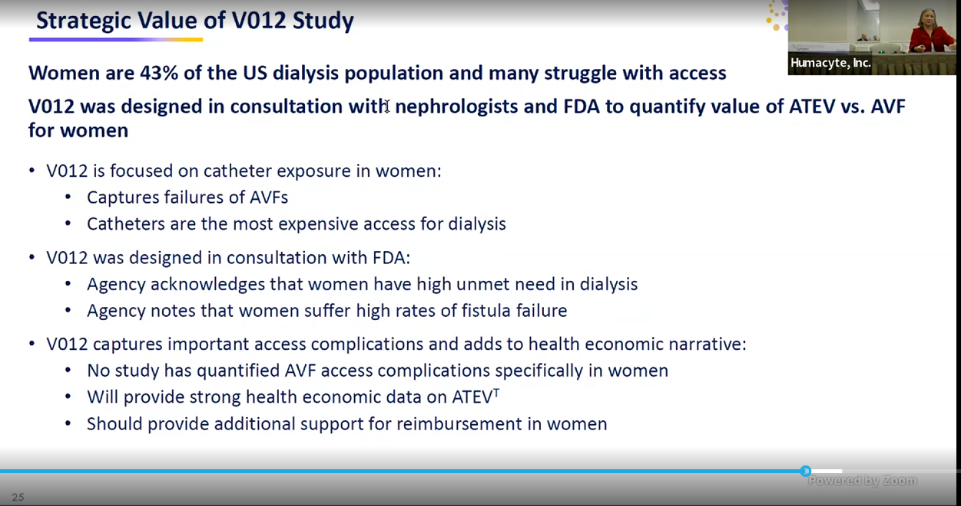
* 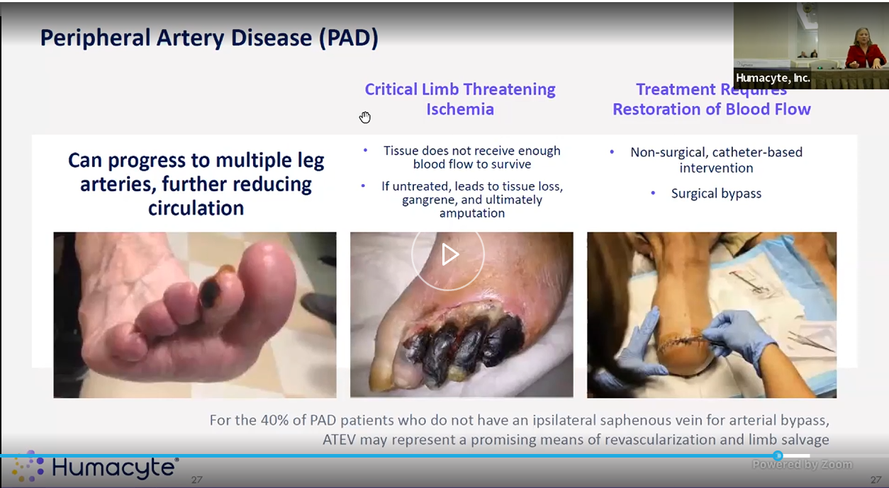
* Skipped thru the following
* 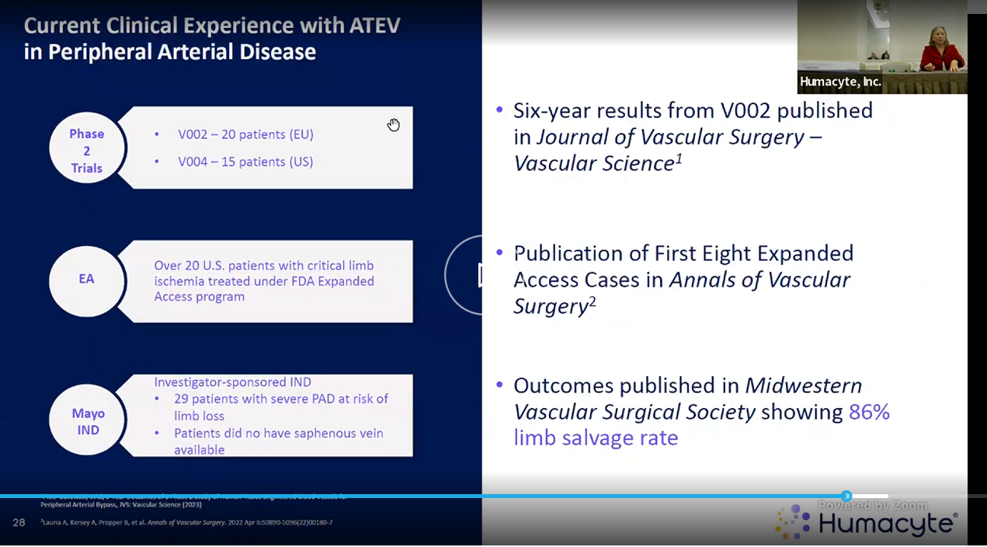
* 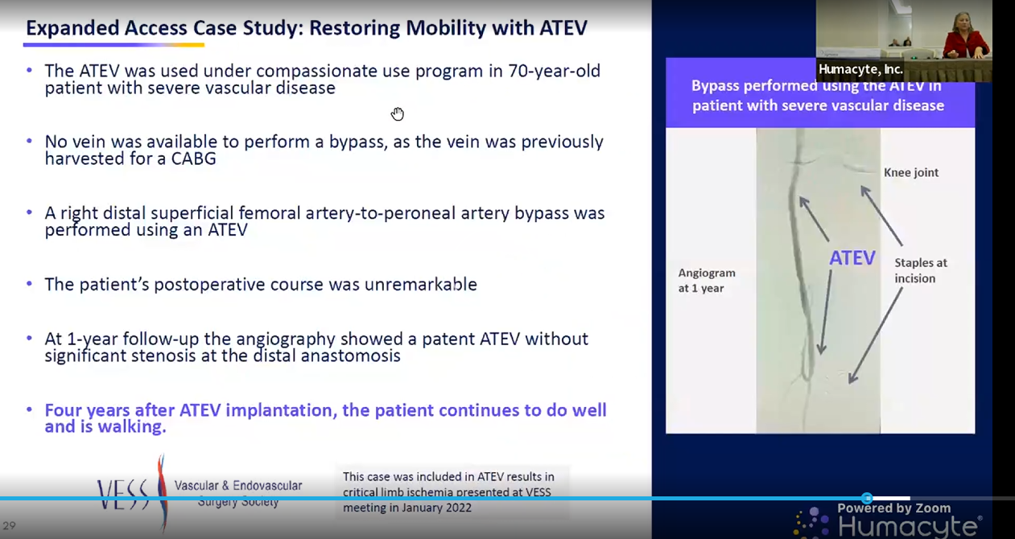
* 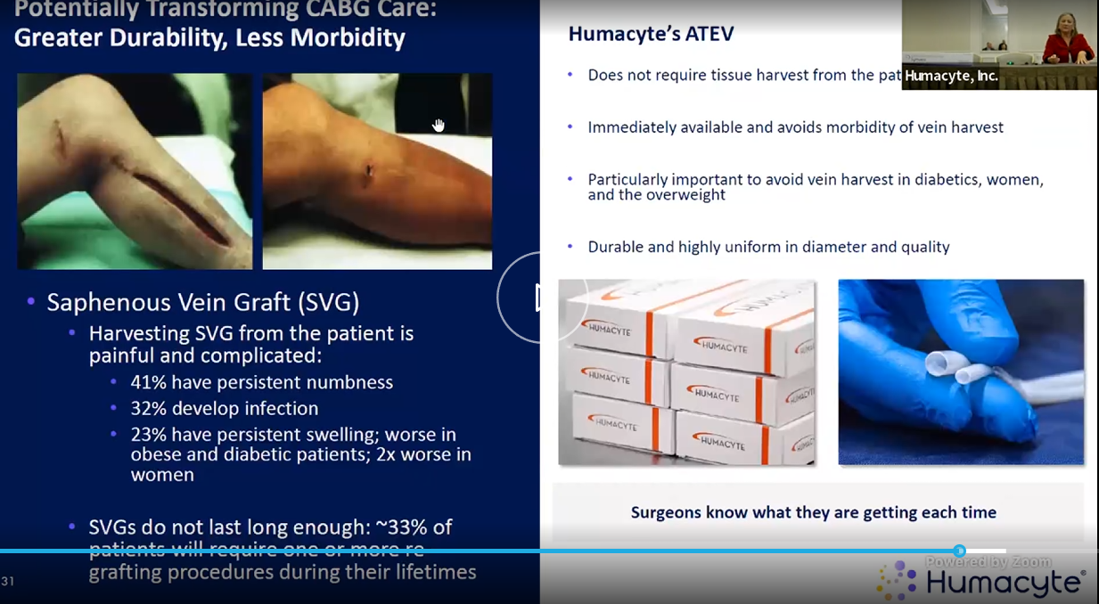
* 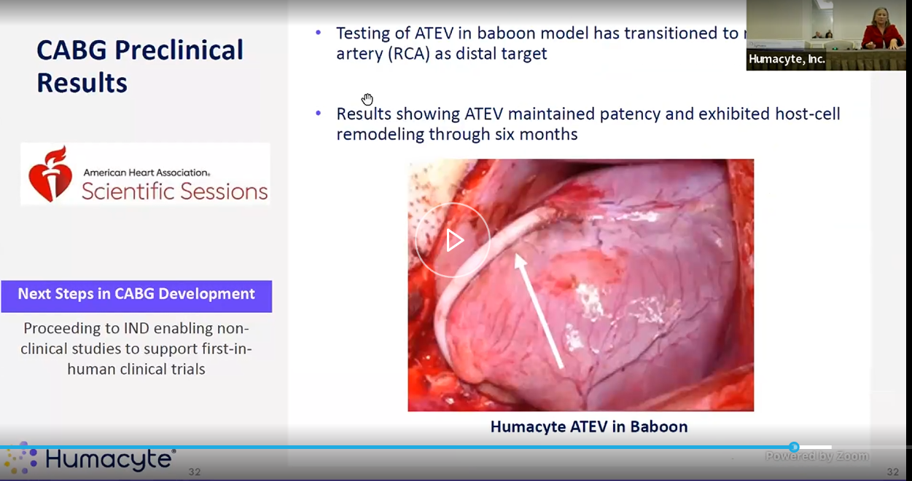
* 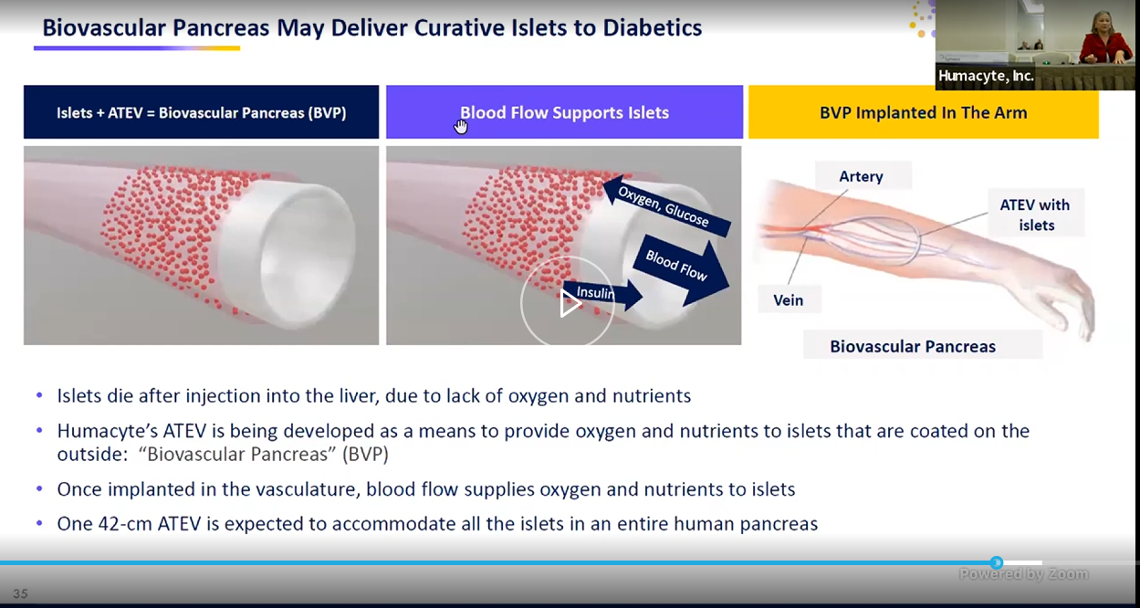
* 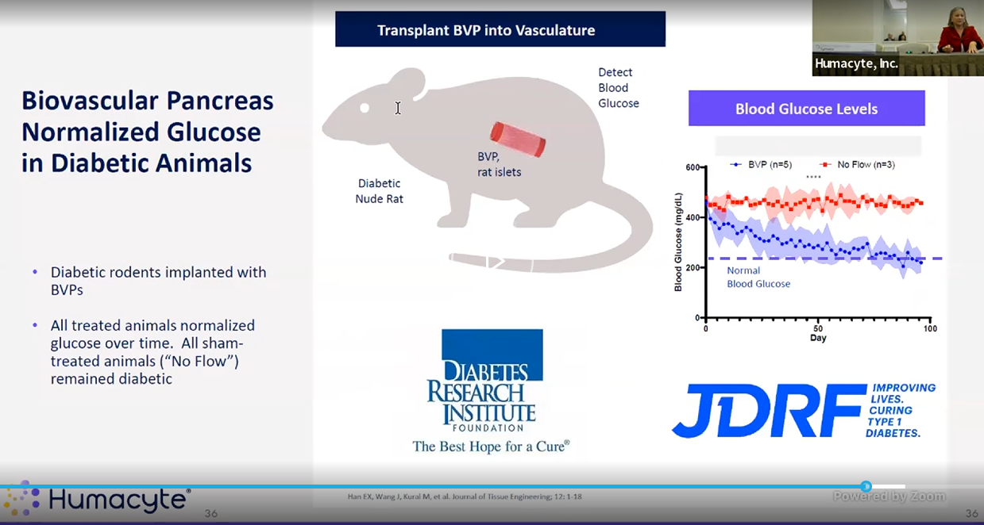
* 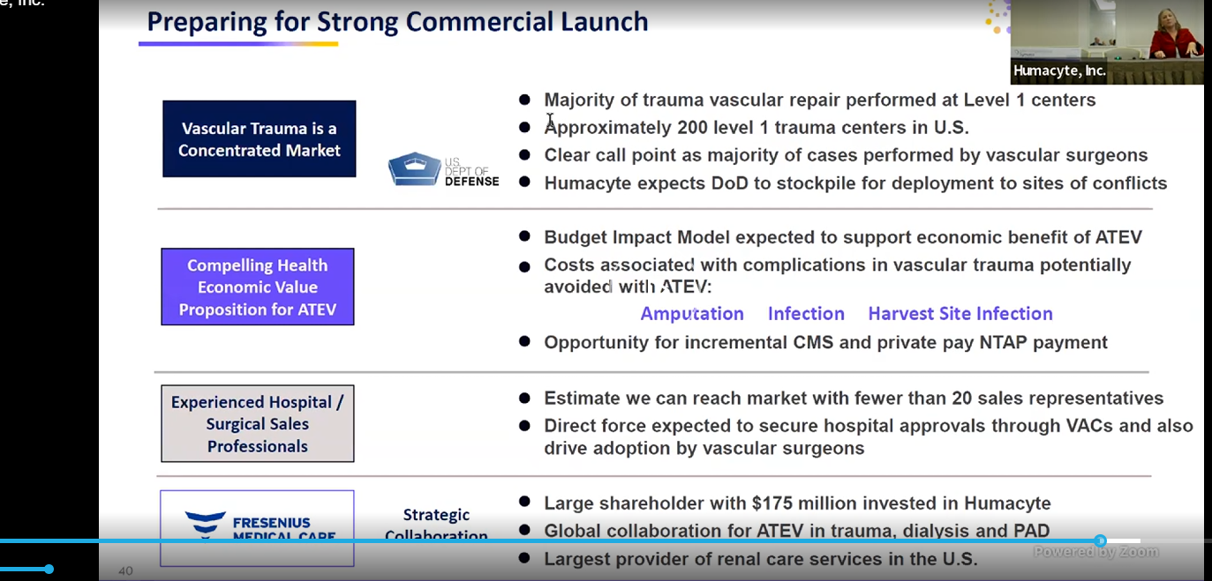
* 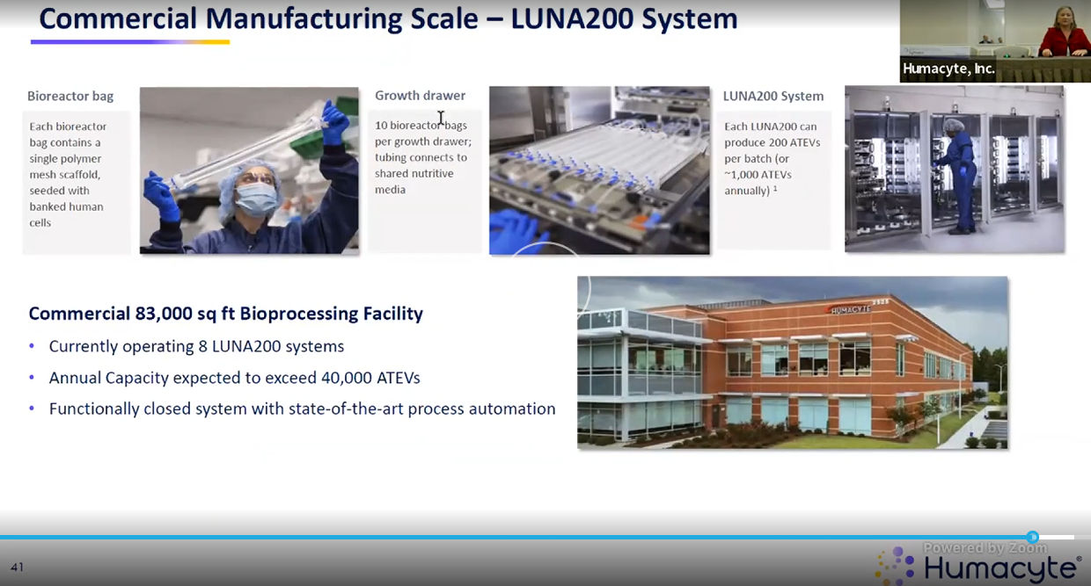
* 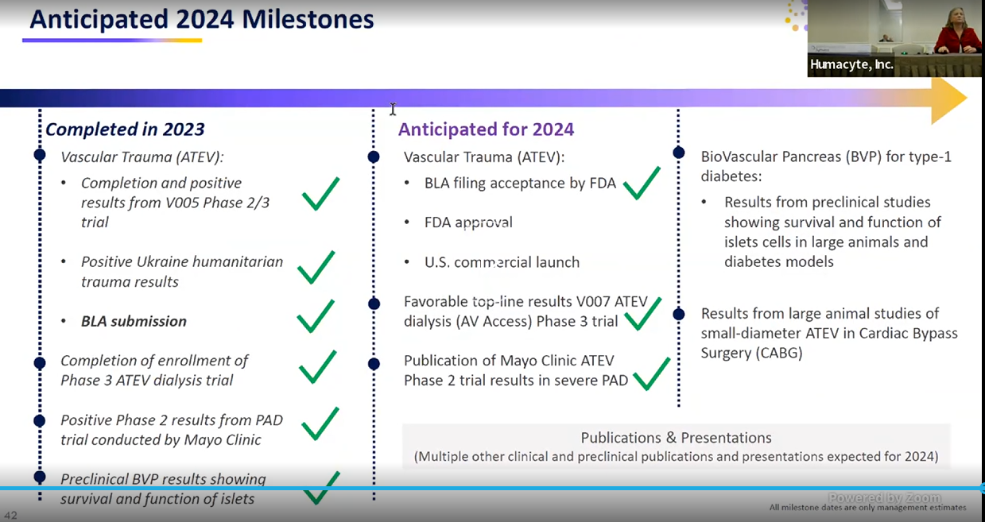
* 20% of facility is actually occupied rn. Rest can be expanded.

KOL Meeting

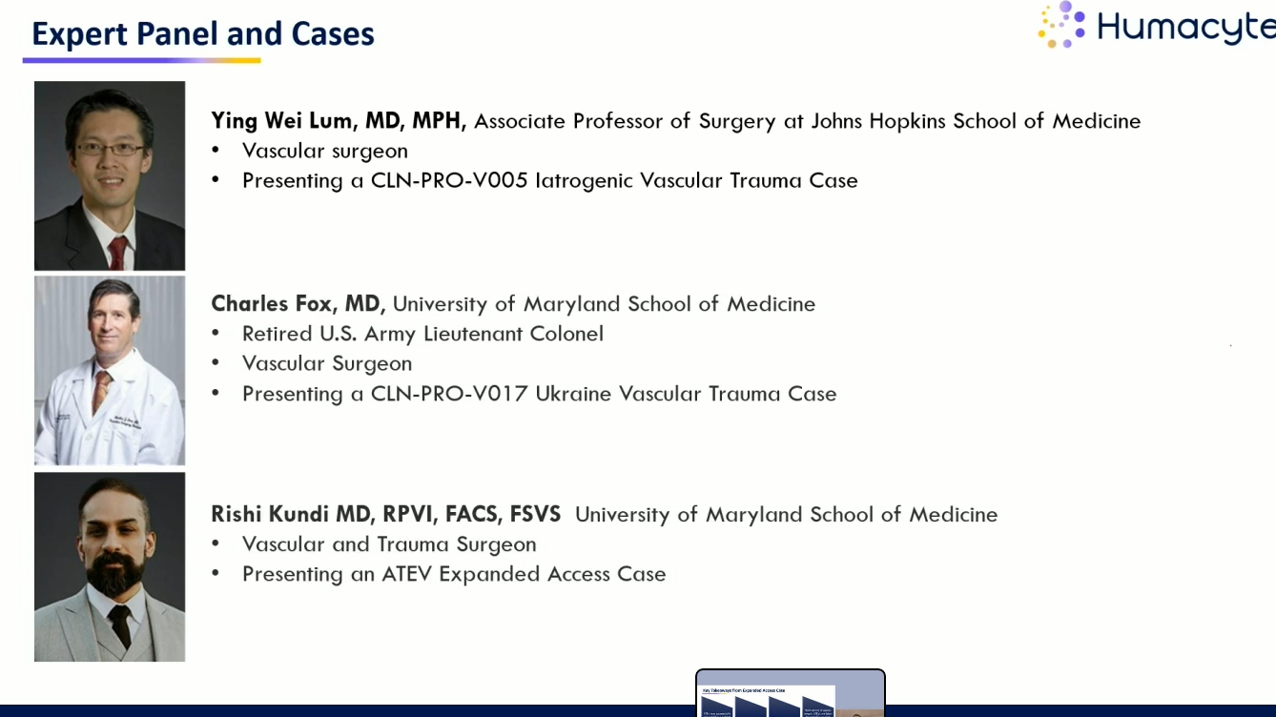

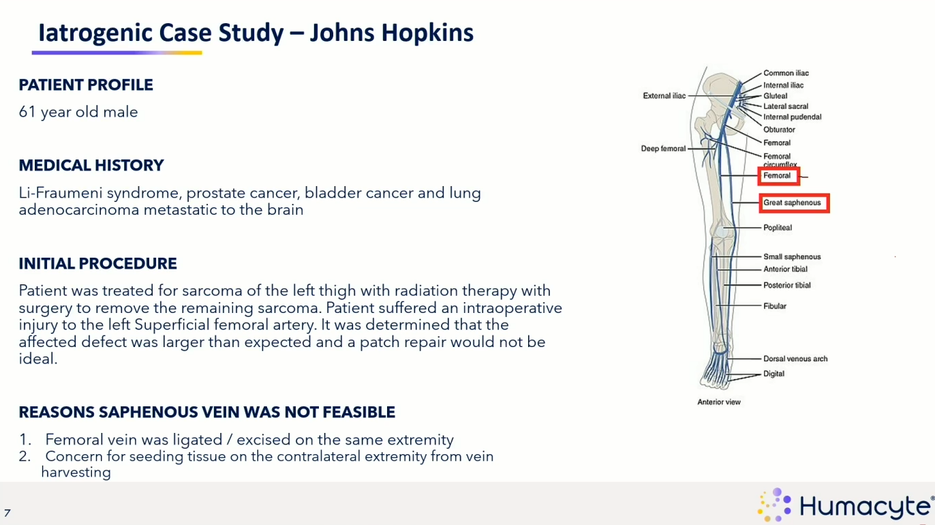

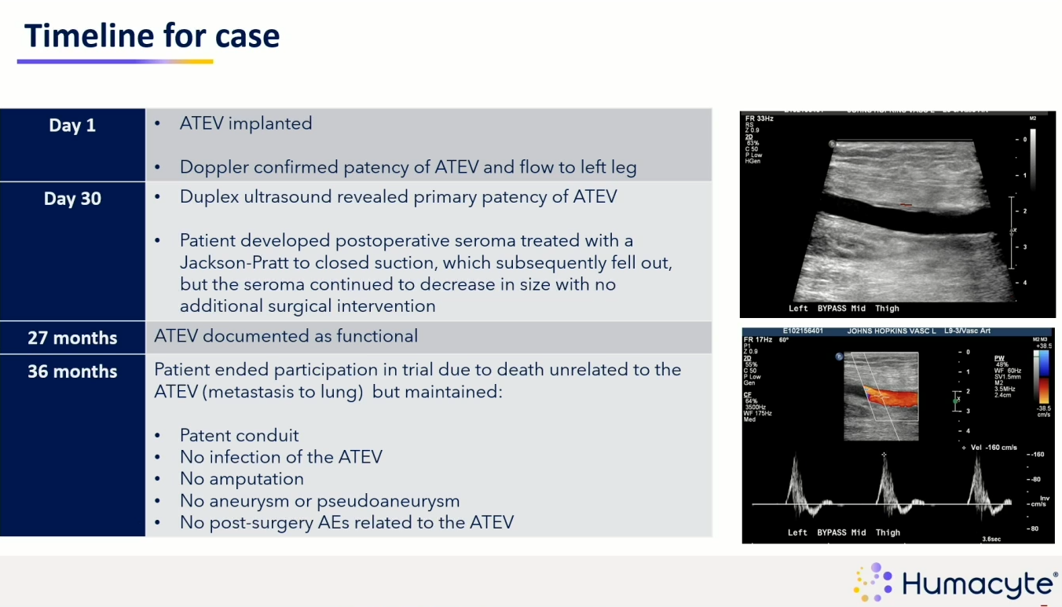

Graft stayed patent, pt died after 3yrs. Off the shelf, doesn’t need to be thawed out, good pt outcomes.

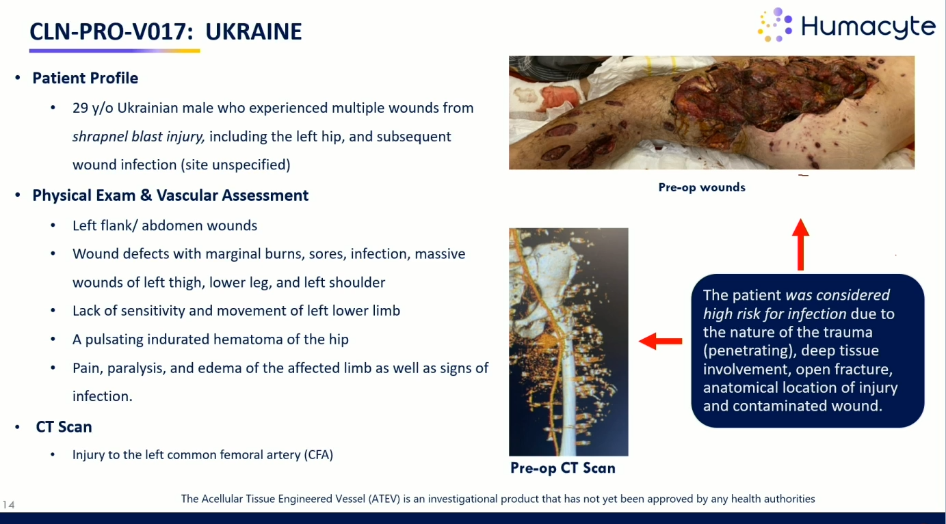

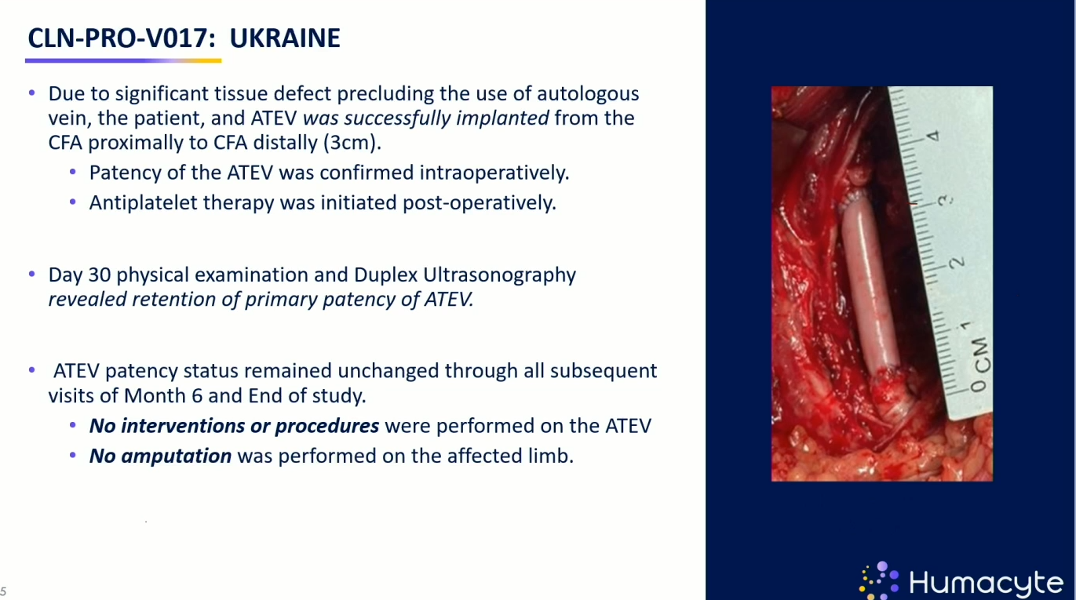

WAS on anti-plaetlet therapy, has primary pat at 30d, has primary pat at 6m

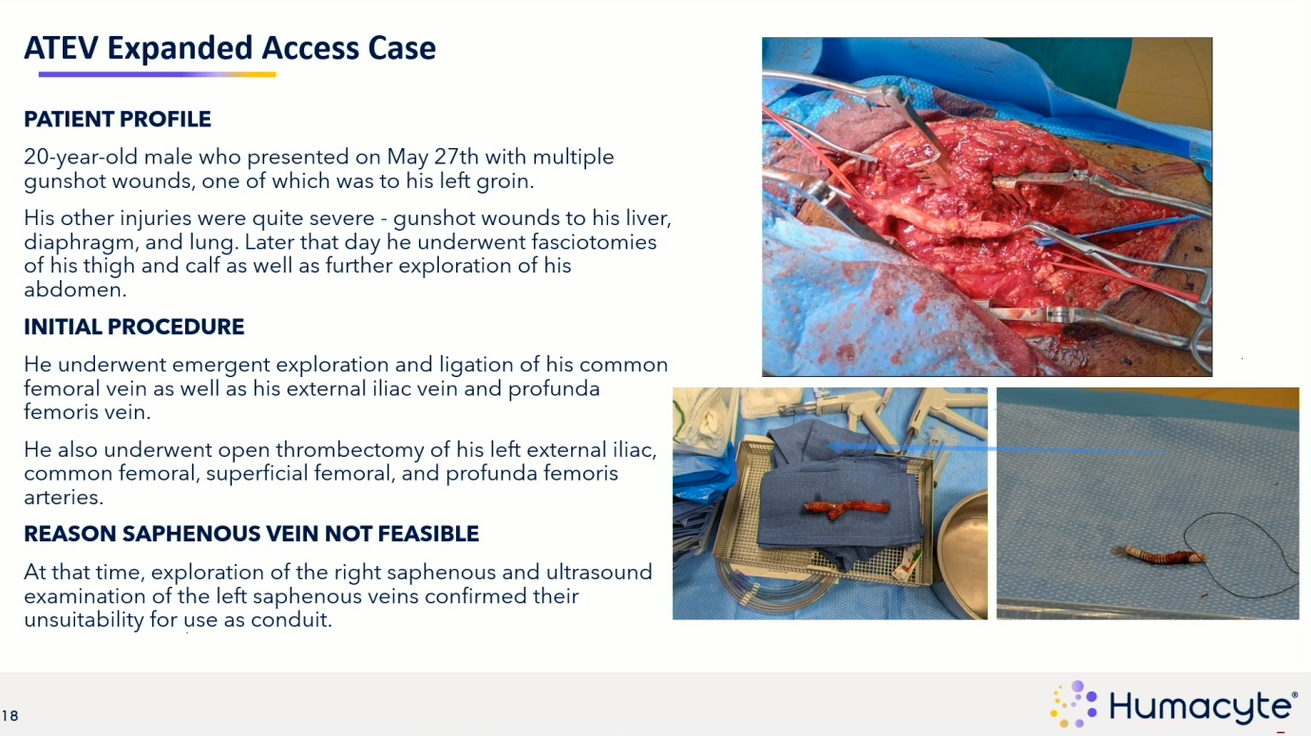

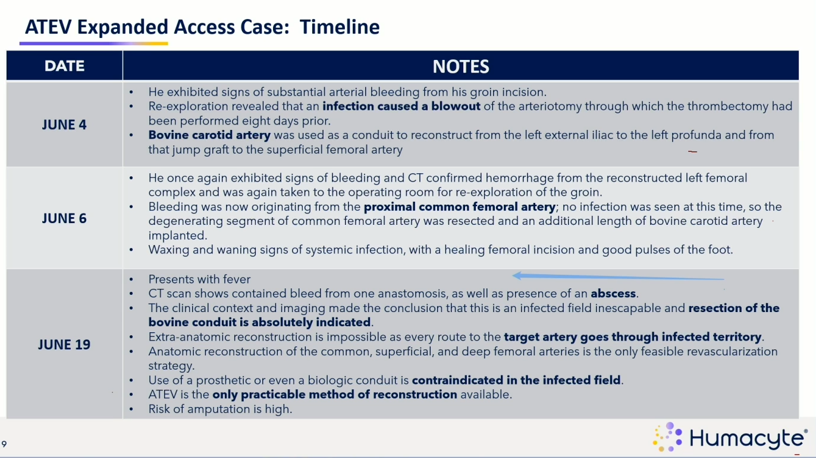

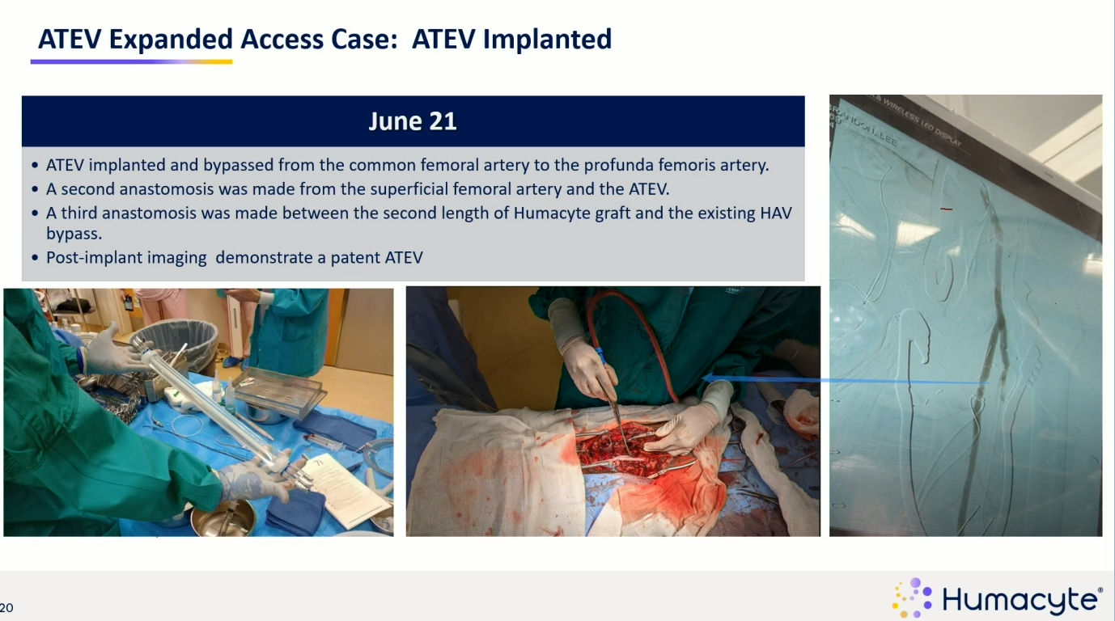

6wks on it’s patent, no infection, looks “native”

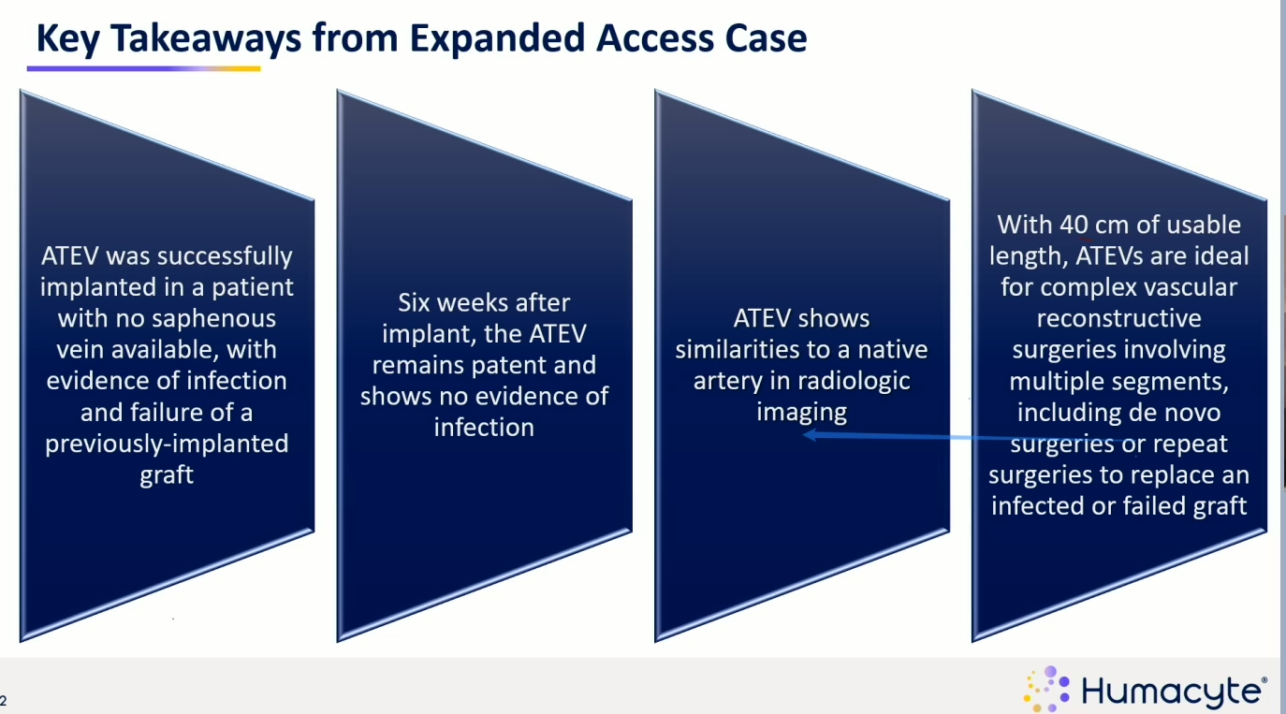

Q&A: what outcomes are you looking at first? Secondary patency?

Rishi: for trauma vascular surgery it’s going to revolutionize field, in Baltimore they don’t have saphenous veins usually (exceedingly high), bypasses are really hard as it is, says it will take the place of prosthetics ever again (<10%)

Charles: miltary a small niche, but speed and accessibility is important, doesn’t think there’s alternatives to ATEV, easily to handle, no needing to take saphenous, “will be my go-to conduit”

Ying: doing a lot of reconstructions, saphenous vein too small (3mm, 4mm, 5mm…6mm better), resisting infection great feature

Laura: “won’t be cheap”, budget impact model, infections avoided, aputations avoided, busy centers would have 3-5 ATEVs on site

Charles wants to use it in dialysis. “they don’t have veins anymore”

Rishi: thinks it will be use all the time, we go thru prosthetics a lot, give a sense of the surgeries we’ll switch to this with

Charles: thinks it will be very useful in war time sitch

Ying: not going to replace saphenous veins but will replace prosthetics more likely

Freq of infections in prosthetics?

Rishi: 2.5-7% in groin femora popliteal infection rate, would rather use ATEV

HUMA has ICD10 codes from CMS, effective this fall for arterial reconstruction in upper and lower extremities

Patency:

Primary patency means that you perform a procedure to restore patency to a vessel, and report how long patency is maintained without any repeat intervention. Primary-assisted patency defines the durability of an intervention that failed initially but not to the level of thrombosis and was retreated. Secondary patency means that the initial intervention failed to the level of thrombosis and was retreated.

https://www.ncbi.nlm.nih.gov/pmc/articles/PMC2386712/  
**Hemodialysis Arteriovenous Fistula Patency Revisited: Results of a Prospective, Multicenter Initiative**  
Primary patency is the intervention-free access survival. Assisted primary patency is the thrombosis-free access survival. Secondary patency ends when the access is abandoned

Risk factors for primary functional patency loss (intervention-free interval) and secondary failure (abandonment) were determined using regression models.

Primary patency (intervention-free access survival) was defined as the interval from time of access placement to any intervention designed to maintain or reestablish patency or to access thrombosis or the time of measurement of patency

Assisted primary patency (thrombosis-free access survival) was defined as the interval from time of access placement to access thrombosis or time of measurement of patency, including intervening manipulations (surgical or endovascular interventions) designed to *maintain* the functionality of a patent access

Secondary patency (access survival until abandonment) was defined as the interval from time of access placement to access abandonment or time of measurement of patency, including intervening manipulations (surgical or endovascular interventions) designed to *reestablish* the functionality of thrombosed access

The word “**functional**” was added to patency to indicate that patency interval started at date of first successful cannulation for hemodialysis treatment instead of date of access placement

Thesis: HUMA is a sell candidate due to its lack of clinical efficacy, questionable safety data and overall lack of data for the indication they are pursuing for approval with their BLA. This thesis relies primarily on an evaluation of the clinical data of the trauma and dialysis indications.

* State the lead product, mention indications it’s pursuing.
* Set context for the indications- patency (define them), and how FDA’s mandate is to approve on safety and efficacy. We will examine both of those perspectives when considering the approval of the ATEV.
* Efficacy- trauma
  + Look at clinical data – V005, V017
    - V005
      * Clin readout table
    - Historical comparisons
      * VAVIS study and data
        + Anti platelet meds
        + Patency at 30days as bridge

Argue that one

* + - Inclusion exclusion criteria
    - Endpoints
      * What they are now
      * What they started as
    - Anti platelet drugs
    - V017
      * Complete lack of inc/excl
      * Ukranian, retrospective, observational
      * Highest reported data ever
      * Endpts
        + Limited time for comparison, 30d, 12m
      * N=16
* Efficacy- Dialysis
  + V006
    - Endpts
      * Functional patency is a made up term
      * Secondary patency
  + V007
* Safety
  + No long term data in any case
  + Infection and amputation rates at what timeline? 30d??
* Finances
* Selling by board member and husband of CEO

HUMA’s lead product is the acellular tissue engineered vessels (ATEV), an artificial vein which is being investigated in many applications but we will look at the two lead indications which are in ph3 clinical trials. Because of the company’s short term cash position the near term clinical catalysts and regulatory approvals will likely determine the outcome of the stock in the next year or so which will be the focus of this analysis.

When considering the efficacy of an artificial vein there are some key metrics to evaluate to determine its clinical effectiveness. Michael Jaff